Version <1.0>

Revision History

|  |  |  |  |
| --- | --- | --- | --- |
| **Date** | **Version** | **Description** | **Author** |
| <dd/mmm/yy> | <1.0> | <details> | Nguyen Kiem Hoa |
|  |  |  |  |
|  |  |  |  |
|  |  |  |  |

Table of Contents

1. Like Image 4

1.1 Brief Description 4

1.2 Actor 4

2. Flow of Events 4

2.1 Basic Flow 4

3. Special Requirements 4

4. Preconditions 4

5. Postconditions 4

6. Extension Points 4

# Like Image

## Brief Description

This use case defines the steps of liking an image. User can easily like all images which make them interesting.

## Actor

User

# Flow of Events

## Basic Flow

User open image from gallery, searching or homepage. Then a new panel with detail information about image appear. After that, user can click on “Like” button under image and number of likes will be increase instantly and name of user who like will be store in database.

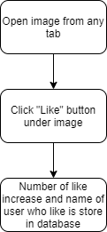

# Special Requirements

1 like/1 image.

# Preconditions

Open an image.

# Postconditions

Number of like increase and name of user who like is store in database.

# Extension Points

No extension point.